FACULTY EVALUATION
Programme Name: Social Entrepreneurship Program (SEP)- START Alumni MASTERCLASS (16th February 2026 - 20th February 2026)
Session: Review (identify gaps/challenges) your business plan from module/ Decide key issues for long-term sustainability/ Identify areas where support is needed
Faculty Name: Dr. James Onyoin
No. of Respondents: 5
No. of Participants: 10
Evaluation Parameter | (%) Individual Score | (%) Programme Average
Punctuality (Commencement and Completion of Sessions) | 65 | 80
How well do you understand the core concepts presented? | 85 | 80
Rate your confidence in applying the new skills learnt | 75 | 74
Degree of Faculty preparedness for the sessions | 95 | 92
Content and methodology of the program | 90 | 87
Quality of class and group discussions | 70 | 74
The information presented in the course is relevant to my work (ministry) | 90 | 88
Average scores | 81 | 82

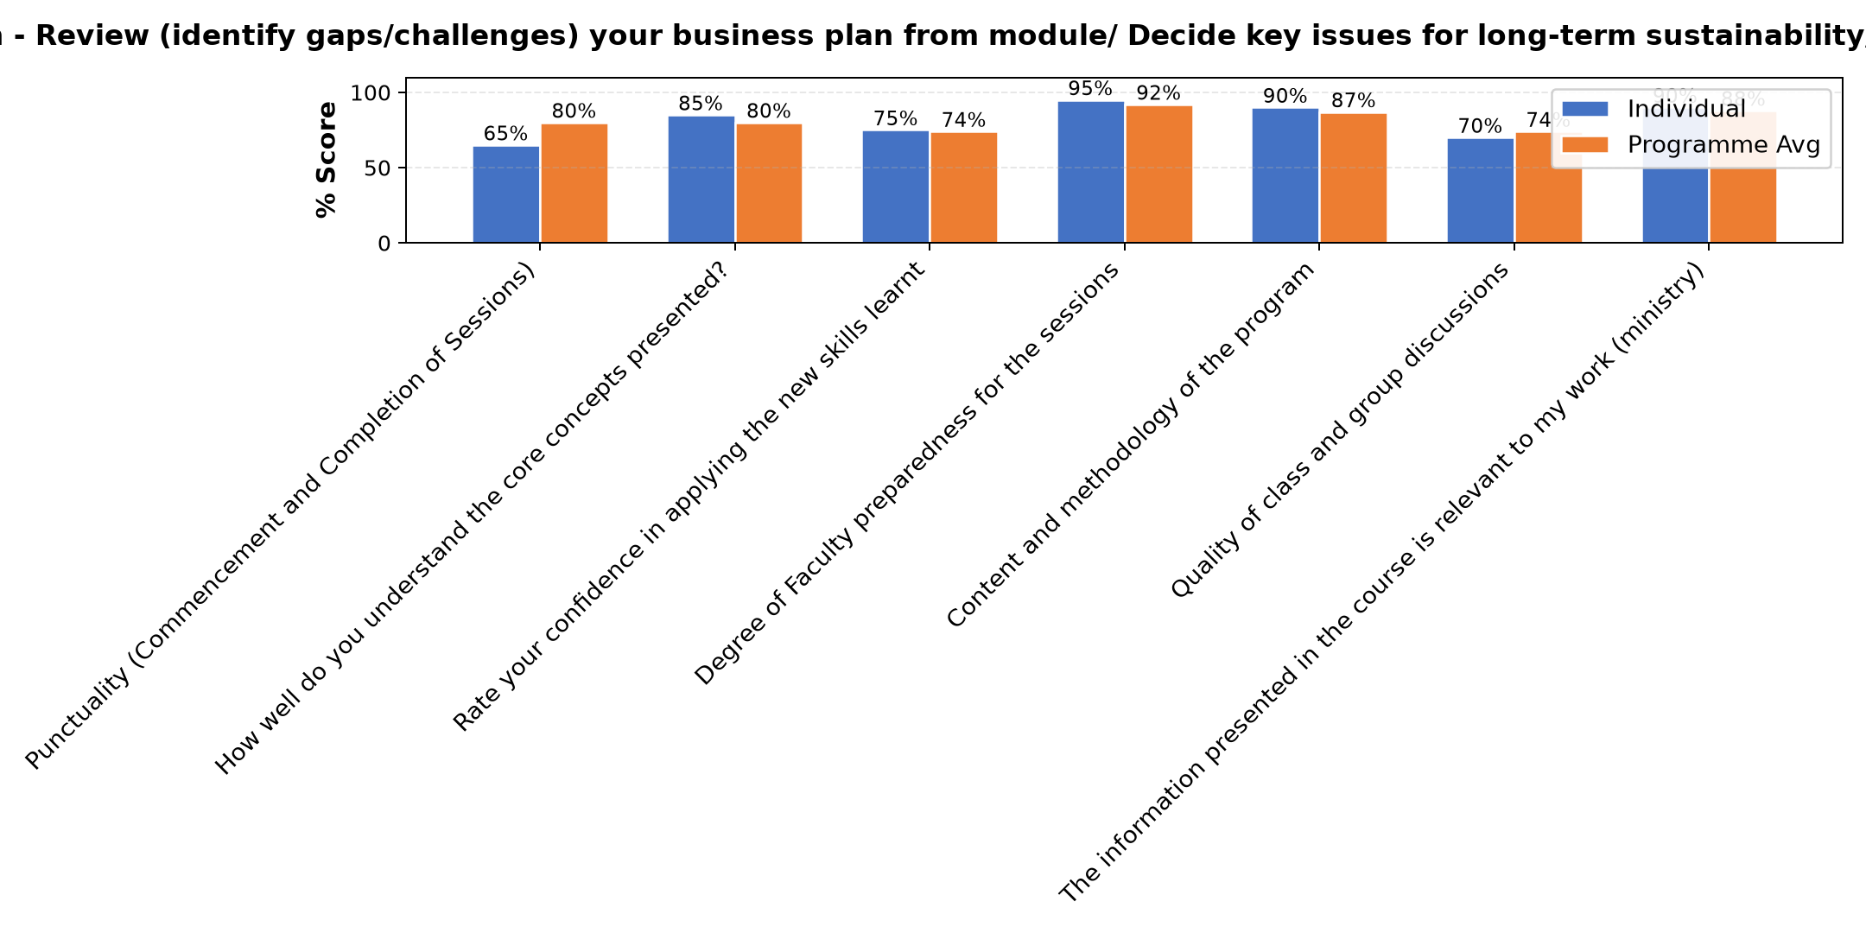

Comments & Feedback
- • Learning will be applied.
- • Distance from the project site
- • Thanks for all support offered.
- • It was good having this follow up session
- • I liked the presentation because it was a way of screening and assessing the work we are doing, what we have missed out, what do we have to apply and how do we do it. Thanks to Dr. James, it was empowering presentation
SUBMITTED THROUGH:
SBS Evaluation Automation System

